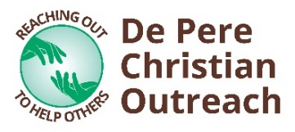
De Pere Christian Outreach Financial Assistance Form
For the past 30 years, De Pere Christian Outreach (DPCO) has been able to help local non-profit organizations through the generous support of the community and our volunteers. We are blessed and honored to be able to share our gifts with others! If your organization would like to receive funding through DPCO, we simply ask that you complete this form. Additional pages may be attached.

Name of Organization: |  |  | Date:
Address:
EIN #:
Representative Name: |  |  | Title:
Phone: |  |  | Email:
Mission Statement and/or Org Goals:
How many people does your org serve annually?
% of budget that relies on fundraising: |  | % of budget is administration:
How much did you raise last year? |  | # of fundraising events this year:

Specify if you are requesting financial assistance for your operating fund or a special project.

Operating Fund
Goals for the year:
How the money will be used:
Total amount Requested: | $

Special Project
Project name: |  | Project timeline:
Project purpose:
# of people this project will help:
Itemized expenses: |  | Total amount requested: | $

Please send completed form to AMurphyDPCO@outlook.com. Thank you!

