De Pere Christian Outreach Non-Profit Financial Assistance Form

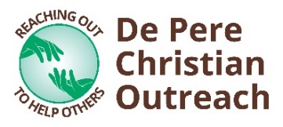
For the past 30 years, De Pere Christian Outreach (DPCO) has been able to help local non-profit organizations through the generous support of the community and our volunteers. If your organization would like to receive funding through DPCO, we simply ask that you complete this form. Additional pages may be attached. Requests are generally reviewed in February, May, August, or October, and approved by our Board within a month after.

Name of Organization: |  |  | Date:
Address:
EIN #:
Representative Name: |  |  | Title:
Phone: |  |  | Email:
Mission Statement and/or Org Goals:
How many people does your org serve annually?
% of budget that relies on fundraising: |  | % of budget is administration:
How much did you raise last year? |  | # of fundraising events this year:

Specify if you are requesting financial assistance for your operating fund and/or a special project.

Operating Fund *One form per year. If approved, the total amount will be split into two payments, approximately six months apart.
Goals for the year:
How the money will be used:
Total amount Requested: | $

And/Or
Special Project *One project per form.
Project name: |  | Project timeline:
Project purpose:
# of people this project will help:
Itemized expenses: |  | Total amount requested: | $

Please send completed form to AMurphyDPCO@outlook.com. Thank you!

